Academic Year - 2025-26 (Even Semester)
Semester – VI
22CS66 - Mini-Project Synopsis
DEPARTMENT | COMPUTER SCIENCE AND ENGINEERING
TITLE OF THE PROJECT | TEXTURE ANALYSIS FOR CAROTID PLAQUE IN ULTRASOUND IMAGES
STUDENT NAMES/ USN/ PHONE/ MAIL ID | Suryaprakash R | Aravinda
 | 1DS23CS230 | 1DS23CS045
 | 7795130671 | 9483458849
 | suryaprakash082005@gmail.com | aravindagopal26@gmail.com
PROJECT GUIDE | Prof. Anita M, Associate Professor , DSCE.
PROJECT - Domain | AIML
PROJECT Problem STATEMENT | Carotid artery plaque is one of the major causes of stroke, and its assessment using ultrasound images is usually performed manually by medical experts, which is time-consuming and highly dependent on the observer’s experience. Due to the low contrast and presence of speckle noise in ultrasound images, accurate identification and characterization of carotid plaque becomes difficult. Hence, there is a need for an automated and objective system that can analyze the texture properties of carotid plaque regions in ultrasound images and assist clinicians in reliable plaque characterization while maintaining efficiency.
Proposed Solution | The proposed solution is to develop a computer-aided diagnosis system that performs preprocessing of carotid ultrasound images to reduce noise and improve contrast, followed by extraction of texture features such as gray level co-occurrence matrix features, local binary pattern features and other statistical texture descriptors. These extracted features are then used to train a machine learning based classification model to distinguish between different types of carotid plaques, thereby providing an automatic and quantitative assessment that can support medical experts in clinical decision making.  In the proposed approach, carotid ultrasound images are first preprocessed to reduce speckle noise and enhance contrast. The plaque region is then selected manually by the user using an interactive region of interest (ROI) selection tool, in which the operator visually identifies the plaque and draws a bounding region around it. This manually selected plaque region is used for further analysis in order to avoid errors introduced by automatic segmentation and to keep the focus of the work on texture characterization.  Texture analysis is performed on the selected plaque region using statistical and structural texture descriptors such as gray level co-occurrence matrix features, first-order statistical measures and local binary pattern descriptors. Plaque vulnerability is assessed using a rule-based analysis of texture and intensity characteristics, particularly gray scale median and homogeneity measures, where low-intensity and heterogeneous texture patterns are considered indicative of vulnerable plaques, while higher-intensity and more homogeneous patterns indicate stable plaques. The proposed system is intended to act as a supportive analysis tool for quantitative plaque characterization and educational research purposes, and not as a standalone clinical diagnostic system.  SOLUTION STRATEGY :  1.The ultrasound image will be preprocessed only for noise reduction and contrast enhancement.  2.The plaque region will be selected manually by the user using an interactive ROI selection tool.  3.Texture features will be extracted only from the selected plaque region using classical texture analysis methods such as GLCM and basic statistical measures.  4.Plaque vulnerability will be assessed using rule-based analysis of texture and intensity features such as gray scale median and homogeneity.  5.The system will provide an indicative texture-based assessment of plaque vulnerability and will not perform model training or automatic multi-plaque detection.  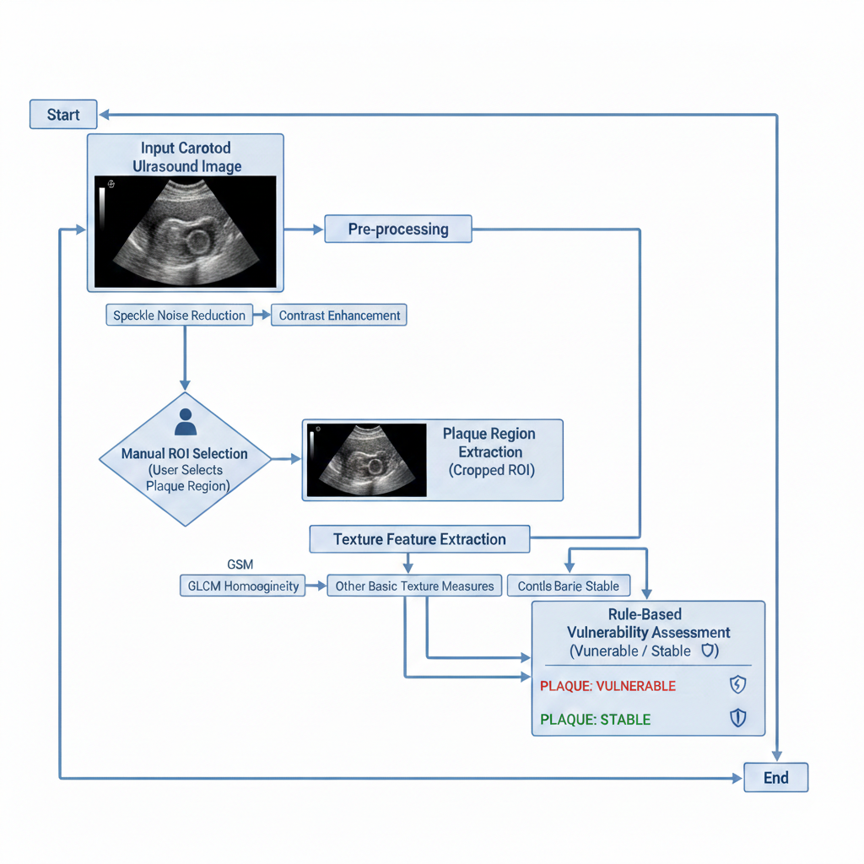
PlaTform that will be used for implementation  (Name the hardware and Software tools and Development Environment  that you will be using for implementation) | Hardware (HW):  - Personal Computer or Laptop  - Minimum 8 GB RAM  - Intel i5 or equivalent processor  Software Tools and Development Environment:  - Operating System: Windows / Linux  - Programming Language: Python  - Libraries: NumPy, Pandas, Matplotlib, Scikit-learn, TensorFlow / Keras  - IDE: Jupyter Notebook / VS Code
 | Programming Language : Python
OTHER DETAILS (if any)

- Dataset will be sourced from open repositories such as Kaggle or UCI Machine Learning Repository.
- The project can be extended to deep learning models like CNNs or RNNs for advanced tasks.

References | [1] Zakarya Hasan Ahmed Abu Alregal, Gehad Abdullah Amran , Ali A. Al- Bakhrani, Saleh Abdul Amir Mohammad , Amerah Alabrah, Lubna Alkhalil , Abdalla Ibrahim and Maryam Ghaar6,  “Carotid plaque segmentation and classification using MRI-based plaque texture analysis and convolutional neural network” , 2025  [2] Lianlian Zhang, Qi Lyu, Yafang Ding, Chunhong Hu and Pinjing Hui , “Texture Analysis Based on Vascular Ultrasound to Identify the Vulnerable Carotid Plaques” , 2022  [3] S.K. Kakkos, J.M. Stevens, A.N. Nicolaides, E. Kyriacou,C.S. Pattichis,  G. Geroulakos and D. Thomas ,  “Texture Analysis of Ultrasonic Images of Symptomatic Carotid Plaques can Identify Those Plaques Associated with Ipsilateral Embolic Brain Infarction”,2007  [4] Scikit-learn Documentation – https://scikit-learn.org  [5] TensorFlow Documentation – https://www.tensorflow.org

